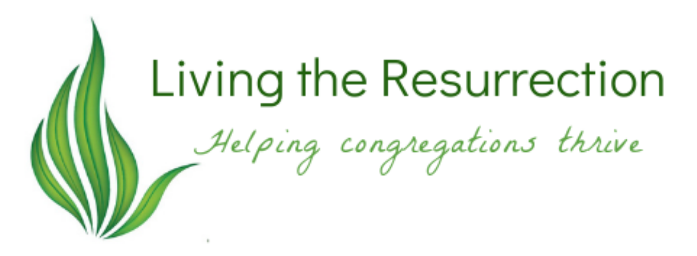

Bias and Defense Mechanisms:

Theory and Practice

Theory
Members love their congregations; through them, they experience and express love for God and one another. But what about loving our neighbors? Our goal is to expand folks’ love to include an active love for their neighbors. We mean all good things, yet some people hear this as a critique of the way they have been living out their faith. If the neighbor is more than just the people in my congregation, have I been doing this wrong my whole life? If I have been serving my neighbors out of a sense of charity, but never understood it as justice, is my faith somehow less than yours – is that what you are saying?
Challenging the way individuals define themselves triggers their psychological defense mechanisms. Denial is probably the most famous defense mechanism, but there are forty-seven others, all of which serve a common goal: to shield us from shame and blame. Humans have a built-in change prevention system that uses both emotion and intellect to manage anxiety. Underlying our feelings and knowledge systems, each of us has a few “Big Assumptions” that are never questioned because they serve an important purpose: they make our long-held convictions and behaviors make sense. But it isn’t only individuals that behave this way; congregations can become victims of their defense mechanisms when their collective underlying beliefs are challenged.

Technical or Adaptive Solutions.
Though some folks think the answer lies in information. If people understand the facts, they’ll respond appropriately. But that only works within specific situations. Technical problems are solved by existing knowledge, meaning this problem has a known solution and we just need to apply the solution and it will be gone. The toilet backs up and floods the narthex. I don’t know how to fix that, but I know who does and I know it can be done. All I have to do is call a plumber and let them take care of it.
Many folks apply this logic to the struggle congregations are having with decline. They work hard to revive something they know how to do because it was successful in their congregation years ago – and nothing happens. Disappointed that all their work was for nothing, they never consider that they have misdiagnosed the problem.
Church decline is not a technical problem. There is no single silver bullet. There is no one way to fix the problem because it isn’t a problem, but a situation that is somewhat unique to each congregation. What is needed is an adaptive solution: A process through which the congregation can discover how to get to know their neighbors, learn from them, and THEN become a congregation their neighbors might enjoy.
Adaptive solutions include intentionally practicing a new way of living. The solution needs to align beliefs and behaviors, meaning the new ideas must be acted on quickly. For example: say I’m working with a group to help them see that God wants them to actively love their neighbors, but I don’t guide them step-by-step to act on that, they may experience cognitive dissonance. When there is a gap between what we believe and how we behave, that dissonance can trigger defense mechanisms. The easiest way to escape the dissonance is to justify ourselves by declaring the new learning incorrect and then regressing to our old beliefs that align with our old behaviors. Justification and regression are just two of the many defense mechanisms at our disposal.

Unintentional Bias Against Diversity
I tend to work with monocultural congregations in multicultural neighborhoods. They don’t know their neighbors and are often surprised when they learn about the people who live in the 3-mile radius around their facility. They have myths about the neighbors and stories they tell themselves that defend themselves against them. “They think we’re irrelevant.” “We’ve invited them to come – we even started a Sunday School- but they never come.” My personal favorite was a group of leaders who agreed that no one could afford to live in the houses around the church. I pushed back with a bit of sarcasm “So these homes are all empty?” No, of course, they weren’t. They sold quickly for lots of money. The truth was that the group was a little intimidated by folks who could afford to purchase those homes. As Martin Luther King Jr said:
People fail to get along with each other because they fear each other. They fear each other because they don’t know each other. They don’t know each other because they have not properly communicated with each other.

Expanding love to include our neighbors often means crossing multiple cultural lines: ethnic, socio-economic, generational, and gender identity are just a few. We have an instinctual bias that interprets difference as a threat. In a study where participants were shown a picture of a group of people who are all one color, and another picture of a group with a combination of black and white people, participants of various ethnicities felt the monochromatic groups would be more peaceful than the mixed groups. Acknowledging this instinct is helpful in that it takes the blame off the individual. We don’t choose to feel threatened, but we can calm it.
The conversation around race intensified during the COVID-19 pandemic, fueled by the murders of George Floyd, Breonna Taylor, and others. These events led folks to read books written to help white people recognize the false social construct of race, the structures that support white supremacy, and how members of the dominant race cling to privilege.
It is essential to consider the racism of our country, our culture, our church, and each congregation as we move toward developing relationships with neighbors who are oppressed by white supremacy. God’s vision of the kingdom is diverse and inclusive, but we have to overcome our unconscious bias against difference to experience it.
Conquering this bias has proven difficult. Mandatory diversity training programs have been part of corporate life for a long time, but they have not been very effective. Turns out, people don’t like to be told what to do, and they don’t agree with any implication that they are racist. Considering our defense system, that’s not surprising. To successfully cross cultural barriers a more subtle approach is needed. Living the Resurrection processes help congregations develop mutual relationships with people who aren’t just like them. Once people get to know each other and care about one another, they become more willing to make the changes they need to make to keep the relationship going. Several studies support the idea that racial attitudes change when people of different groups “socialize naturally.”

Practice.
It’s easier for folks to begin their learning from a distance. Doing a demographic study of the neighborhood from the comfort of your computer is less stressful than knocking on doors.
Step 1: Demographic Study.
General Demographics of Our Neighborhood by Zip Code.:
The US Census Bureau keeps all sorts of statistics on every city and county in the country. The link below will take you to the Quick Facts page. There’s a search and start your search with the county or city name.
https://www.census.gov/quickfacts/fact/table/US/PST045221
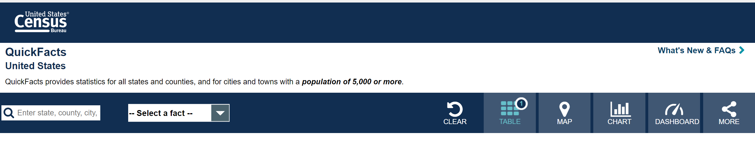
Enter your city or county name here and then click the and select “Population” that will give you the population numbers as well as the % for each race category.
Play around on this site to learn more – check out the maps too!

Step 2. Add Data from your Local School Districts
What are the public schools within a few miles of the church? What school district’s boundaries is your church facility inside?
Search the websites of the local school district and you should be able to find links to the schools near the church. Once you are on the school website, search for the School Accountability Report Card (type SARC into the search box). Each public school creates a SARC report which includes demographic and socio-economic information about its student population.
What’s the school’s mission statement?
What are they excited about?
What are the demographics of their students?
What % of students are on free/reduced lunch?
How many are in the number of students in ESL-type programs?

Step 3: Crossing Cultural Lines
According to the demographics of your neighborhood, what cultures will you cross to engage with your neighbors? ethnic, class, gender identity, generation, or others?
What do you already know about how to work across these cultural lines?
What assumptions do you hear the folks in your congregation make about folks from a different culture?

Step 4 What have we done so far?
What anti-racism resources have you used in your congregation?
How was it helpful?
What are your next steps?
Step 5 What can we do next?
Here are some resources that could be useful as your next step. Each of them includes ways to put your new learning into action.
- “Dialogues On: Race: A new small group series to explore race and the church” is a Sparkhouse resource available at https://www.wearesparkhouse.org/store/category/286991/Dialogues-On-Race
- “The Hate U Give” by Angie Thomas and “See No Stranger” by Valarie Kaur are both excellent books with reader guides and actions. Available wherever you buy books.
- “Uncomfortable Conversations with a Black Man” – book and video series available at https://uncomfortableconvos.com/
- “What Lies Between Us: Fostering First Steps Toward Racial Healing” Dr. Lucretia Carter Berry. 8 Sessions. Journal/Guide is available on Amazon as a print-on-demand resource. Uses the film Race: The Power of Illusion. Brownicity.com or https://www.amazon.com/What-LIES-Between-Journal-Guide/dp/1544106866/ref=sr_1_1?crid=1E7LY58DABN06&keywords=what+lies+between+us%3A+Fostering+first+steps

Deutschman, Change or Die.
Kegan and Lahey, Immunity to Change, 56.
Martin Luther King Jr., “The Martin Luther King Jr Papers.”
Burrell, 74.
Dobbin and Kalev, “Why Diversity Programs Fail.,” 51.
Dobbin and Kalev, 56.
Emerson and Woo, People of the Dream.

